By popular demand, we are doing one final order for this season (practice jerseys only). Please complete the table below and send your orders to Jen Griffiths at ncravp@gmail.com. Once order is received, you will be emailed with a total for the e-transfer. Orders will be open until March 30th with payments due by Friday March 31st.

Jersey Info:
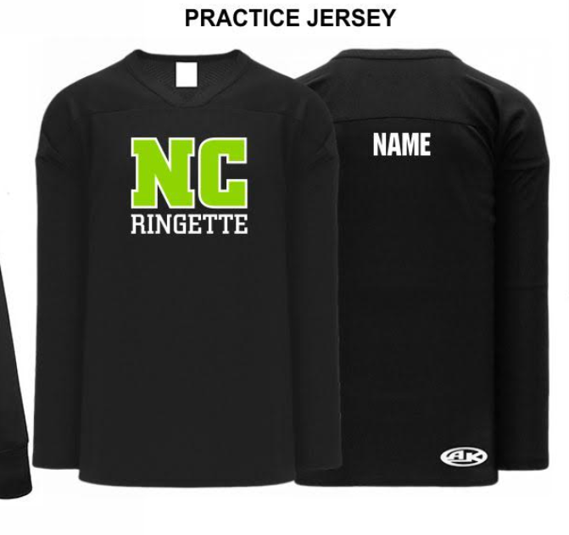
Practice Jersey
https://www.athleticknit.com/practice-hockey-jerseys/h6000-001
$20.10 (ys-yxl & s-xxl)
$25.10 (goalie)

** add $5.00 for player name on back **

 | Player 1 | Player 2 | Player 3 | Player 4
Parent Name
Email to be used for E-Transfer
Player Name
Name on Jersey ($5)
Youth Practice Jersey Size
(YS – YXL)
Adult Practice Jersey Size
(S-XXL)
Youth Goalie Practice Jersey
(YS-YXL)
Adult Goalie Practice Jersey
(S, L, XXL)

